**Name:** Jane Doe

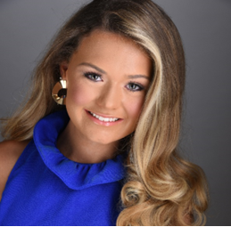



**Title: CONTESTANT**

**Instagram Handle:** @ Answer

**TikTok:** Answer

**Age:** Answer

**Platform Title: “**Answer”

**Talent:**

**Education: “**Answer”

**Education & Professional Objective: “**Answer”

**Honors & Achievements: “**Answer”

**Leadership Positions: “**Answer”

**Employment Experience: “**Answer”

**Special Skills & Activities: “**Answer”

**What can you do during your Tenure of Service as a Titleholder to impact your community?**

**“**Answer”

**What has been your involvement with your platform?**

**“**Answer”

**What inspired you to first become involved in your platform?**

**“**Answer”

**If you are selected as the winner, how would you mobilize and market your platform?**

**“**Answer”

**How would you utilize social media in order to positively further your position as a titleholder if you are selected as the winner?**

**“**Answer”

**What do you want to do as a Titleholder to make a difference in your community?** Answer

**What have you done in your community with your platform before participating in this program?** Answer

**What ideas and/or plans do you have for the near future regarding your platform?** Answer

**What made you to first become involved with your platform?** Answer

**If you are selected as a Titleholder, what will you do to get others involved in your platform?** Answer

**How will you advertise and promote your position as a Titleholder?** Answer

**How will you promote the Miss Greater Hazleton Scholarship Organization?** Answer

**What will you do during your Tenure of Service as a Titleholder to impact your community?** Answer

**What has your involvement with your platform been to date? What plans do you have for the immediate future regarding your platform?** Answer

**What inspired you to first become involved with your platform?** Answer

**If you are selected as the titleholder, how will you mobilize and market your platform locally and statewide?** Answer

**Other than your platform-related messaging, in what ways will you utilize social media in order to positively further your job as the titleholder and the Program as a whole?** Answer