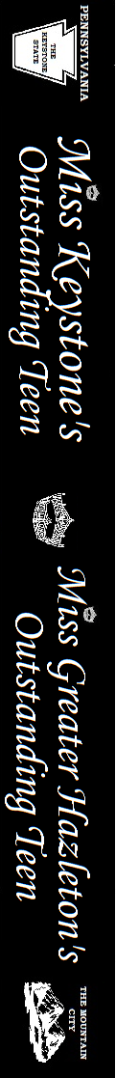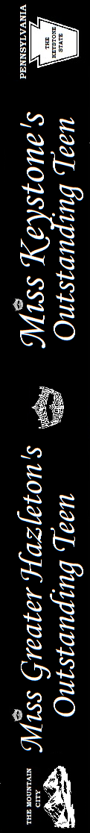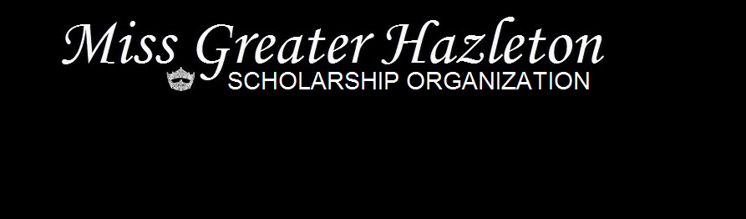

Proudly Presents

**Miss Keystone’s**

**Outstanding Teen**

**2015**

*Claudia Stroia*

“A World

Without Bullying”

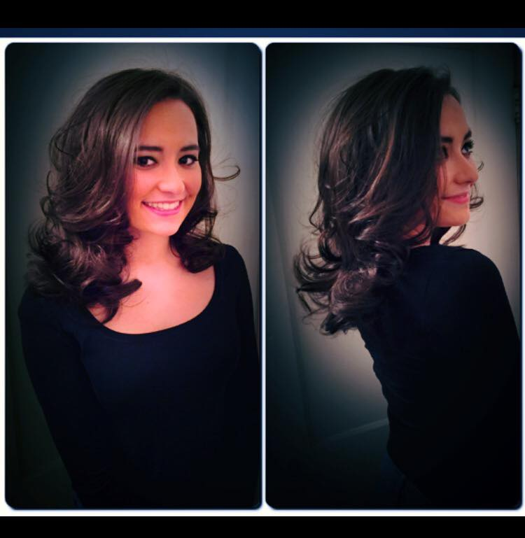

**Miss Greater**

**Hazleton’s**

**Outstanding Teen**

**2015**

*Julia Snyder*

“Melanoma Awareness”

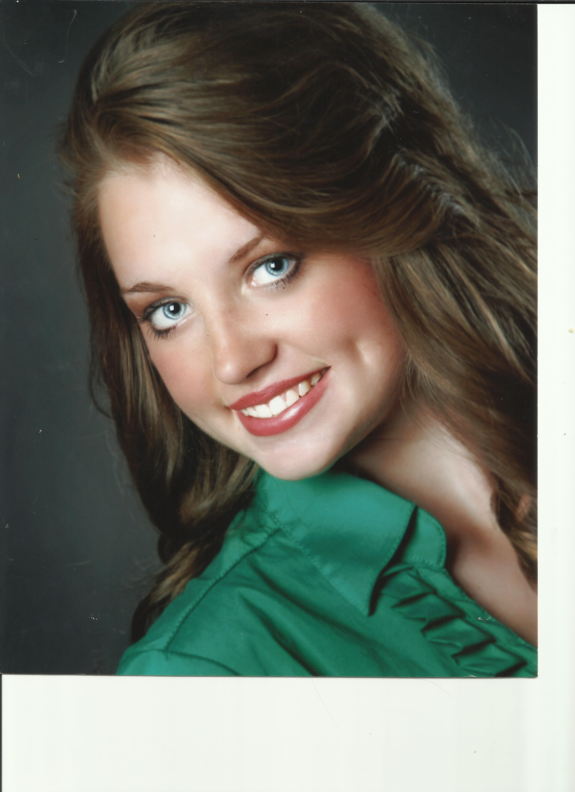

Sponsored *&* Supported by Greater Hazleton Area Businesses

