Name:
Ashley Summers
CONTESTANT
@ashsummers29
21
Title:
Instagram Handle:
Age:
Platform Title:
Talent:
The Salvation Army
Jazz Dance “The Mirror”
Education:
The University of Alabama School of Business pursuing a Master
of Accountancy
Graduate of the University of Alabama – Bachelor of Science in
Finance, minor in Accounting
St. Bernard School – classical honors school
Professional Objective: To complete a Master of Accounting from the University of
Alabama School of Business and pursue a career as a Finance
Manager. Ultimately, I want to serve as CFO of The Salvation
Army.
Honors & Achievements: University of Alabama Chancellor’s Award; Dean’s List for four
semesters; Beta Alpha Psi; The Salvation Army Volunteer of the Year; Selected as one of 12
nationwide volunteers to attend National Advisory Organizations Conference 2018; Volunteer
for Student Disability Services; Outstanding Student of Merit; Jack O. Tomlinson Endowed
Scholarship; Created “Let’s Cheer for the Volunteers” fundraiser for area local high schoolers to
participate; Answered phones for annual hospital telethons from 2017-present; Outstanding
Citizen Award; Wrote and published a children’s book about serving as a Volunteer called “Raise
Your Hand” available for purchase on Amazon.
Leadership Positions:
University of Alabama Graduate Student Association Vice
President; Founded “Serve It Up!” fundraiser for local Salvation Army chapter; Created Race for
the Cure team; Raised $12,000 for three regional Salvation Army chapters over the past four
years; Volunteered over 400 community service hours for The Salvation Army at the local, state
and national organizations; Resurrected the “Save the Seniors” event that was previously held
annually to engage local seniors shut-ins; Mayoral proclamation for “Ashley Summers Day of
Service” in Benton County; Organized “Climb for the Stars” event along with a committee to
raise funds with rock wall climbing event; President, Stay Beautiful campaign; Filmed regional
PSA for the West Tennessee regional Salvation Army chapter.
Employment Experience: University of Alabama Campus News Reporter; Intern, JP
Morgan; Dog Walking Service, 11 years; Dog nanny for four Cavalier King Charles Spaniels;
Babysitter; Dance Instructor, three years.
Special Skills & Activities: Raised over $10,000 for CMN Hospitals through original
fundraisers; I began working at age ten; I have three sisters; I am a published author; I have
visited four countries; I love animals more than most people; I served as towel girl at the
Celebrity Basketball Tournament in my hometown; I was the subject of our newspaper’s
monthly Community Spotlight feature earlier this year; My secret wish is to win an Olympic gold
medal.

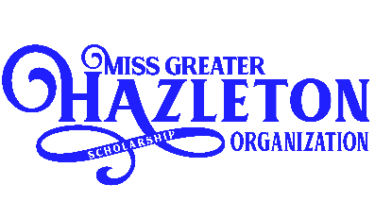
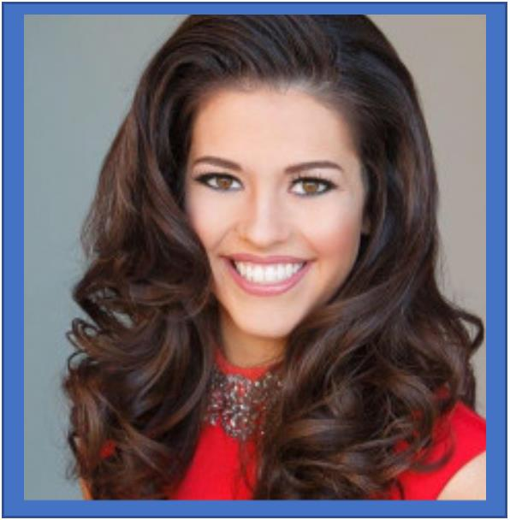
MISS RESUME PROFILE

What can you do during your Tenure of Service as a Titleholder to impact your
community? I want to shine a national light on The Salvation Army and the work they are
doing impacting thousands of unemployed Americans who are hungry and have lost their homes
during the pandemic. I would be honored to serve on the National Advisory Council to add
visibility to the job of Miss Greater Hazleton as well as learn even more about national
initiatives. I would love to broaden my current local Help Rescue Christmas project by
garnering support from all of my state titleholder sisters to form a Help Rescue Christmas
campaign team to fill the growing need of food and shelter.
What has been your involvement with your platform, including time commitment,
strategic planning and ways your ingenuity and resourcefulness have been
demonstrated? In working with The Salvation Army for the past six years, I have volunteered
for numerous events but my favorite was creating “Let’s Cheer for our Volunteers” with my high
school cheer squad. We recruited sponsors to donate $1 for each cheer we could do on Spirit
Day that lasted from our early afternoon pep rally through the Homecoming game that night.
We had an online donation avenue, as well as going door to door to increase our reach and
number of sponsors. By the end of the night, we had raised over $1,200 and had no voice left!
What inspired you to first become involved in your platform? At the age of ten, I
began a dog walking service as an after-school activity to help my neighbors. What started out a
favor to friends turned into a lucrative business for my age. At Christmas, I wanted to do
something special for others and took as many dollars as I could wad up in my pocket to drop off
in a red kettle for iconic The Salvation Army bell ringers. I was so excited to think of the people
my dollars would be helping and still raise as many dollars as I can for this remarkable
organization.
Besides the opportunity to win scholarships, what made you choose to participate
in the Program? Service--I want to improve my community by
implementing programs that can meet people where they are and help get them where they need
and want to be. I want to remind my friends that even connecting through virtual events, we
can easily raise money change someone’s life. If you love running, then you can have friends
and family sponsor a mile and stay healthy while helping those who have lost their jobs during
the pandemic.
How would you utilize social media in order to further the position and job of a Miss
Greater Hazleton Titleholder? I will help make the job of a Miss Greater Hazleton Titleholder as an influencer by increasing frequency of posting, gaining new followers and establishing the brand. I will work toward these goals through original content from daily stories of Makeup Tutorials during appearance preparation to IGTV posts sharing about the special people I encounter during my appearances. I will do a weekly recap of the week’s events with everything from the daily grind of packing and travel to the more glamorous events—it always helps to showcase it all. When appropriate, I will go live during events where I am appearing to share where I am traveling, what I am doing and who I am meeting. I will create Sponsor Spotlight Sundays to thank those who make the Miss Greater Hazleton Scholarship Organization possible and showcase their tangible and intangible donations. I will continue to increase awareness about all of the fundraisers and events for my platform, the Salvation Army, and hold monthly virtual “Tea with Miss Greater Hazleton” events to raise funds for Help Rescue Christmas.

